**BomberMan Return**

**(An Android Game Application)**

**Brief Report**

Sanjiv

Thanh

Cameron

Aisha Alandijani

# **1. Introduction and Project Scope**

For this project, a 2D game application is being developed for the android operating system in smart phones and tablets. It aims to remake the known 80's game "Bomberman ". In the game, player basically try to reach the other players by exploding the walls and try to kill other bombers to be the last man standing. The player should be able to explode all the enemies before a specific time finishes.

# **2. Main Use Case Scenario**

As the application launches, the user should be able to start playing. The player then start moving around and he can place bombs to kill enemies. The player should be aware of where he places the bomb so he doesn’t kill him self and end the game. Another way to lose the game is not being able to kill all the enemies before the time finishes. However, if the player was able to kill all the enemies, he will win the game.

|  |  |  |  |  |  |
| --- | --- | --- | --- | --- | --- |
| **Use Case Name: Move Player** | | | **ID : UC - 1** | | **Priority: High** |
| **Actor: User** | | | | | |
| **Description: The user should be able to move the player by touching the screen** | | | | | |
| **Trigger: User starts the game.** | | | | | |
| **Preconditions:**   1. **User launch the application.** 2. **User select play button** | | | | | |
| **Flow of Events:**   1. **The user launch the application.** 2. **The application asks the user to start/quit the game.** 3. **The game starts.** 4. **The user move the player by touching the screen. .** | | | | | |
| **Post conditions:**   1. **The application should update the animation of the player.** | | | | | |
| **Summery Input** | | **Source** | **Summery Output** | | **Destination** |
| **The x and y coordinates.** | **User touching the screen** | **Movement of the player** | | **-** | |

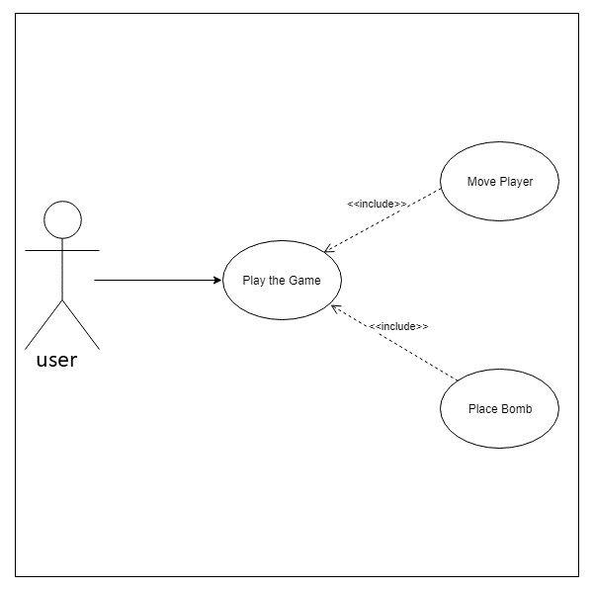

Figure : UseCase Diagram

# **3. Main Functional Requirements**

* The user should be able to start/end the game.
* The user should be able to move the player by touching the screen.
* The user should be able to place bombs.
* The system should be able to play sound.
* The system should be able to center the screen.

# **5 Class Diagram**

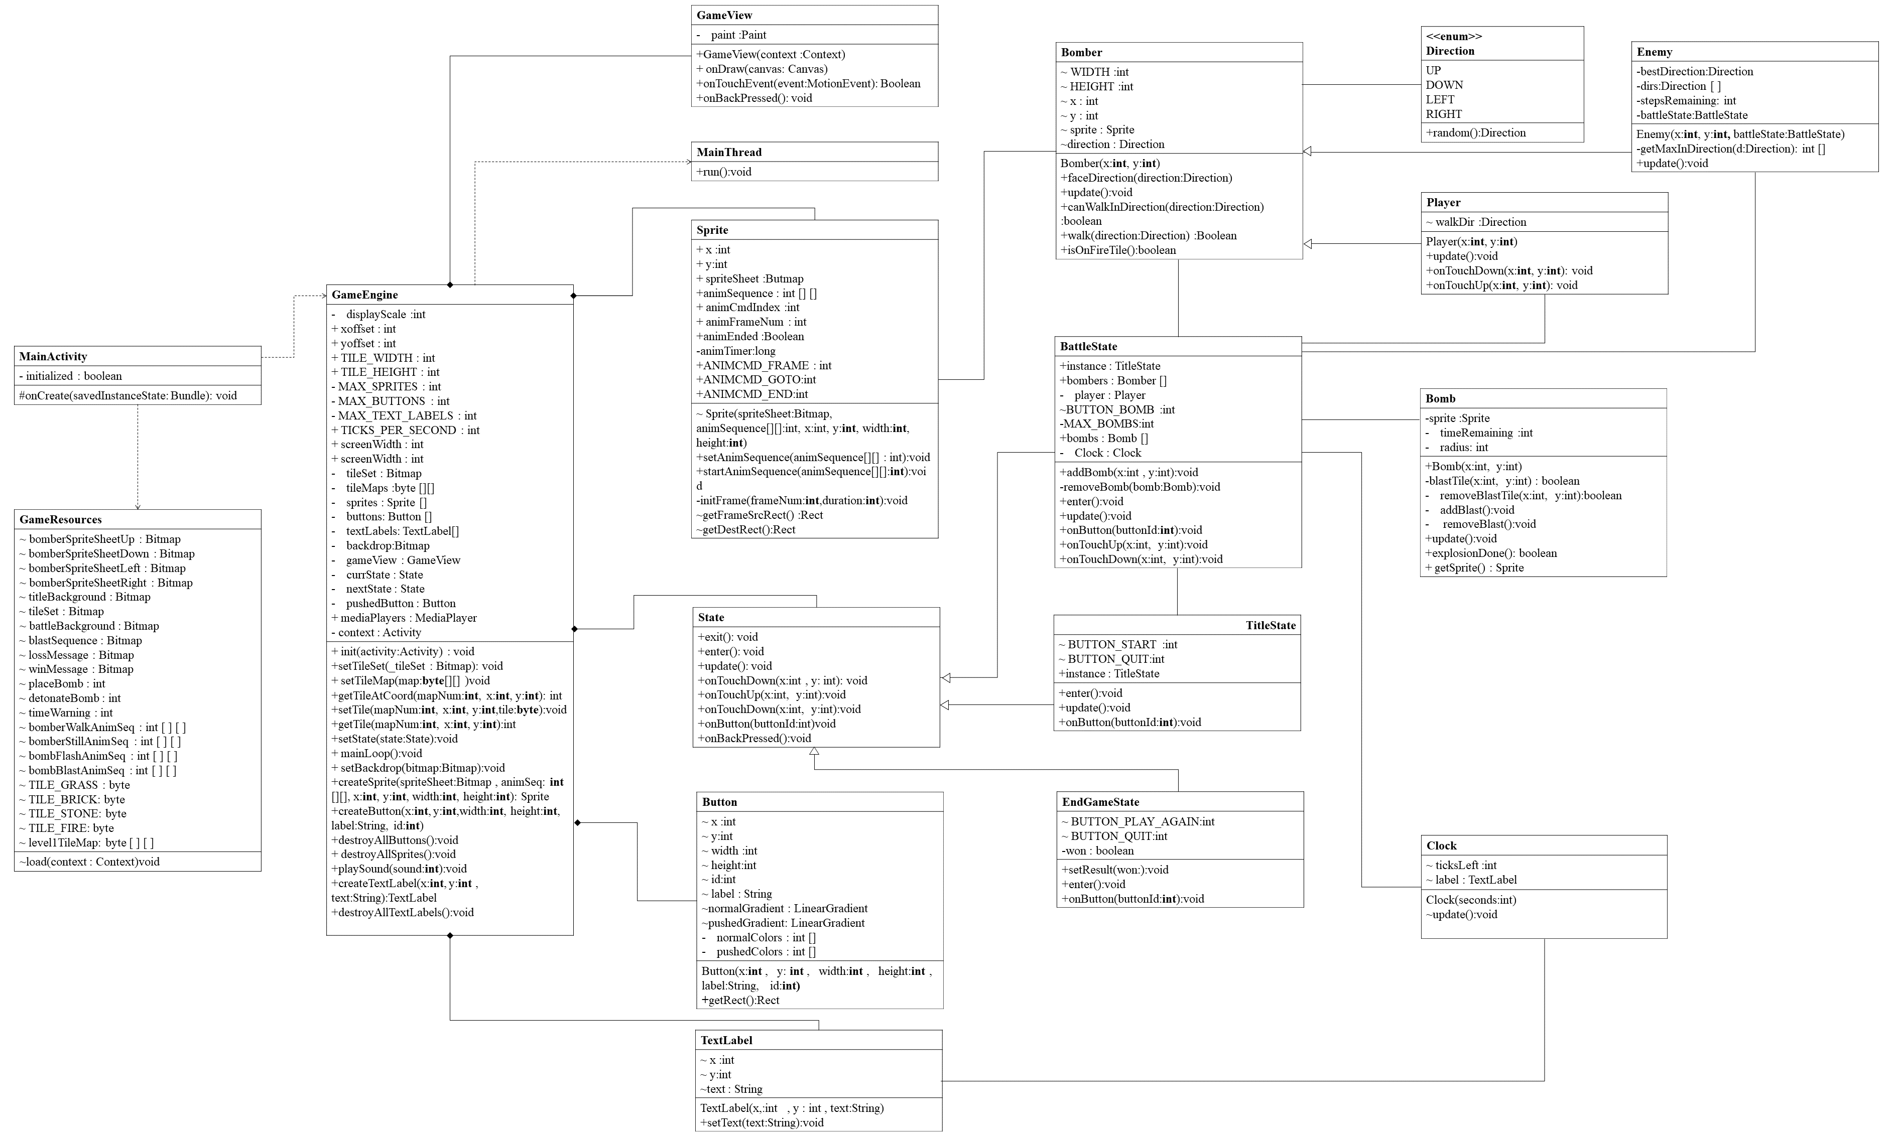

Figure :Class Diagram

# **6. Sequence Diagram**

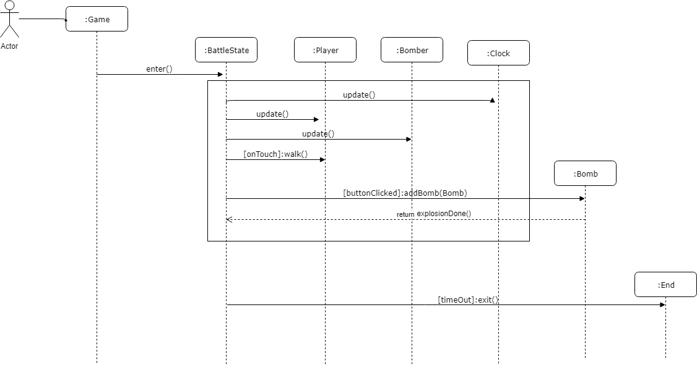

# **7 User Manual**

* You need and android device to play this game.
* Once you launch the application, choose play to start the game.

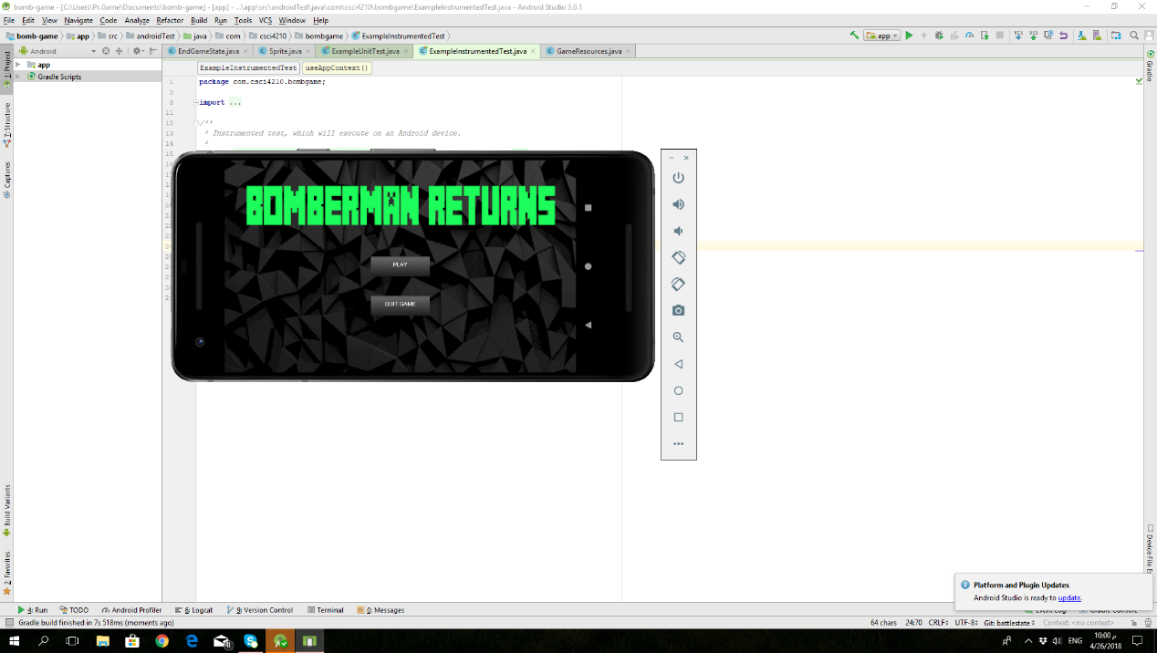

Figure : UserInterface: Start Page

* You can move the player by touching the screen; the center of the screen is adjusted by the player movement.

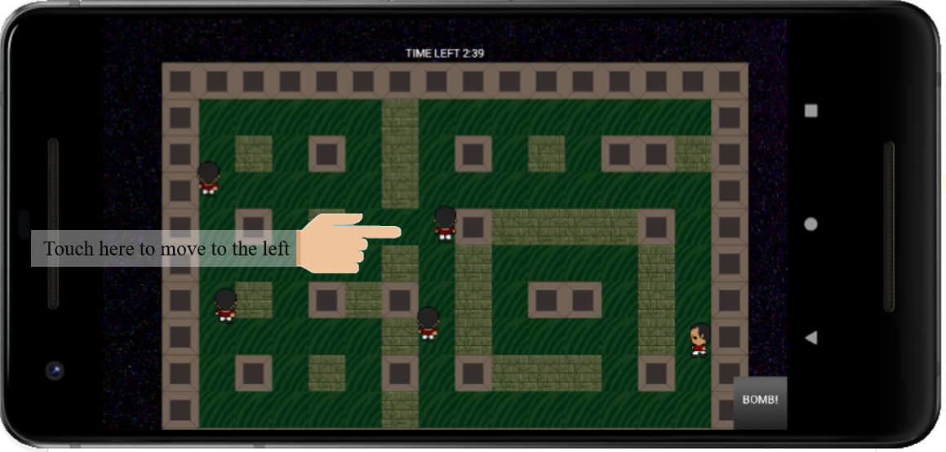

Figure :Move Player by Touching the Screen

* Remember the goal of the game is to kill all the enemies before the time finishes.
* Place bombs to kill the enemies, be aware not to kill yourself, the explosion expands as far as three blocks from the bomb position.

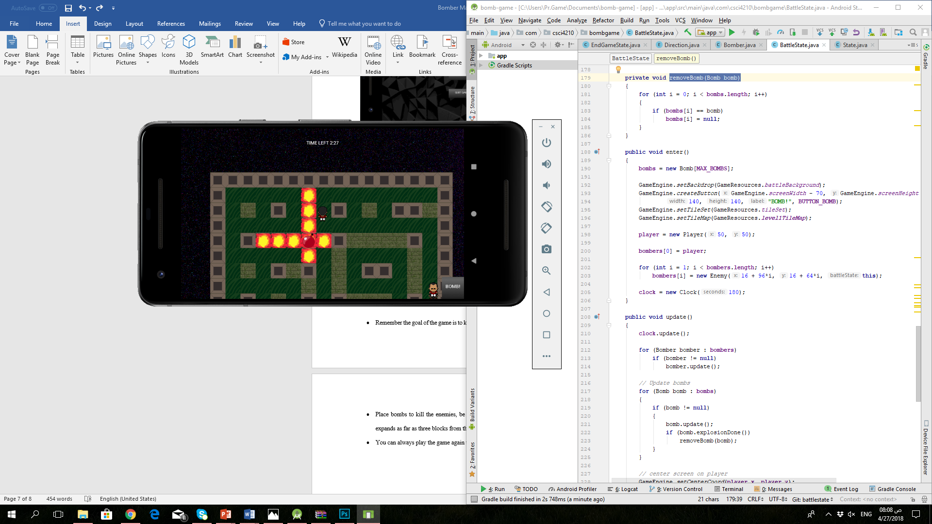

Figure : Bomb Explosion

* If you lost, remember that You can always play the game again until you win.

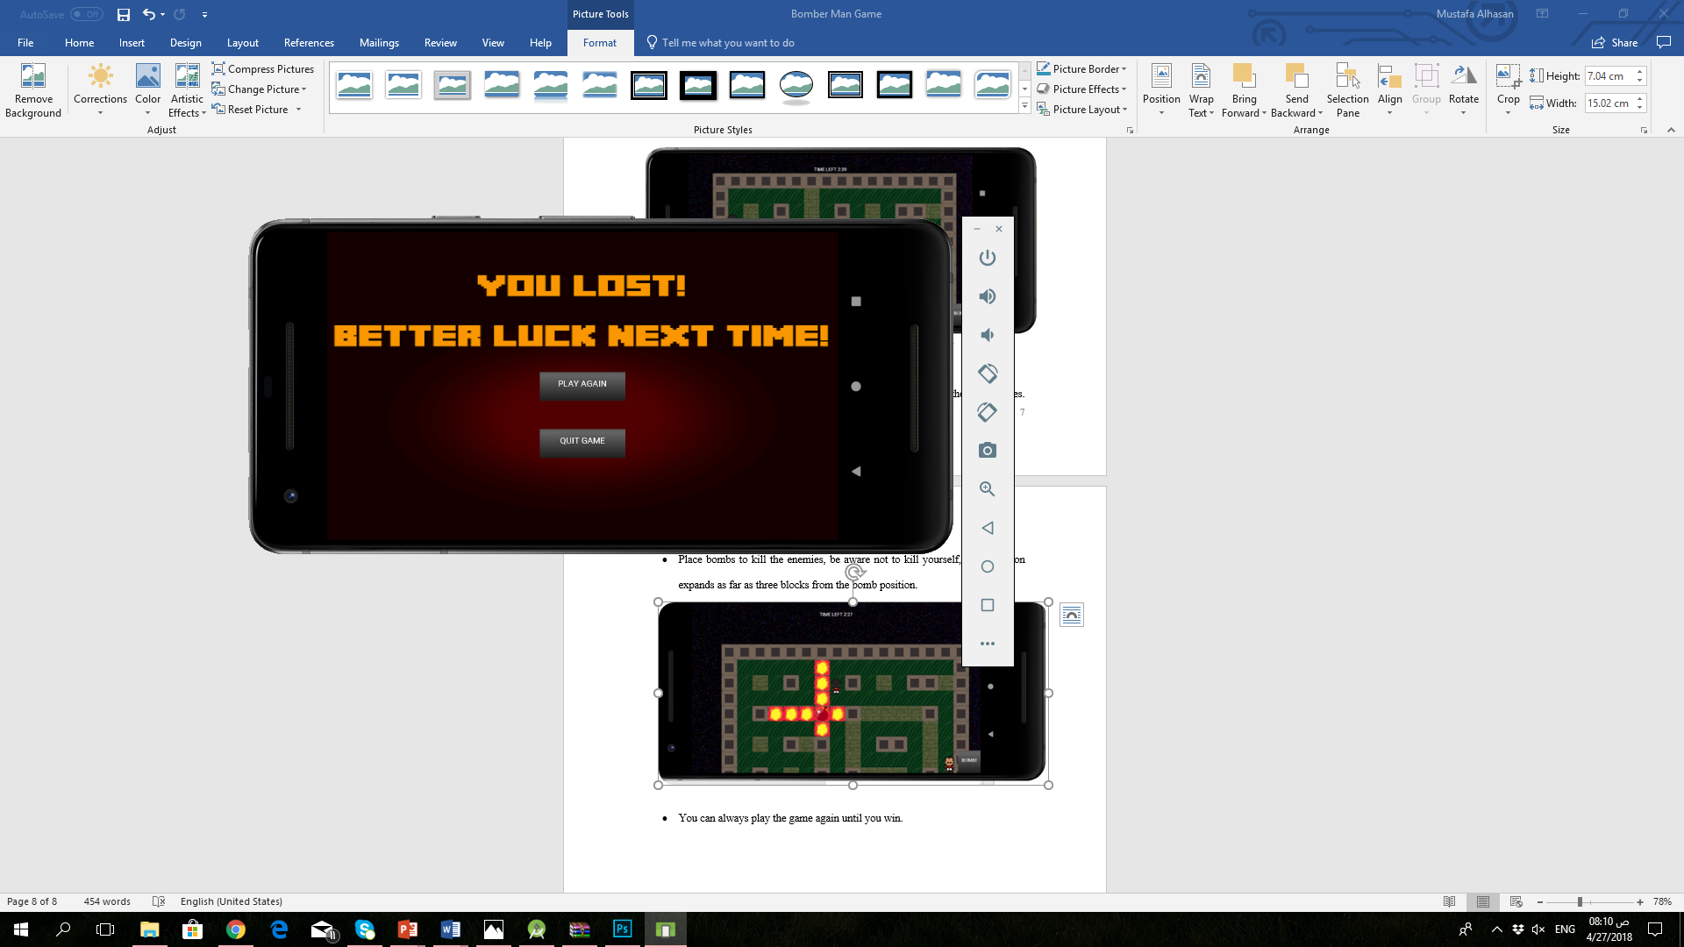

Figure :Play Again Screen